**COP 1000C Intro Programming Concepts**

**Assignment 6**

**Include the use of ++, += in a program that achieves the following using loops.**

**(You can do these in one program or each one in a small program, it doesn’t matter.) (25 points each)**

A. Create a loop that will output all the multiples of 5 that are greater than zero and less than 60 (do not include 60). 5, 10, 15, 20, 25, 30, 35, 40, 45, 50, 55

B. Create a loop that will output all the numbers between 1 and 200 that are evenly divisible by both 2 and 7.

14 28 …

C. Create a loop that will calculate the sum of the multiples of 8 that are between 100 and 500. Output the sum only.

D. Create a loop that will output the sum of all odd numbers between 50 and 100.

**Deliverables:**

1. The code and output screen shots for all four problems above in one word file. (no design tool required).

Send email to me if you are stuck, confused, want to chat about it.

#include <stdlib.h>

#include <stdio.h>

main() {

printf("Integers divisible by 5; 0 < i < 60.\n");

int i = 1;

while (i < 60) { // While loop to demonstrate “for loop”

if ((i % 5) == 0) { // without for keyword.

printf("%i ", i);

}

i++;

}

printf("\n\n");

printf("Integers divisible by 2 and 7; 1 < i < 200.\n");

for (int i = 1; i < 200; i++)

{

if (((i % 2) == 0) && ((i % 7)) == 0) {

printf("%i ", i);

}

}

printf("\n\n");

printf("The sum of integers divisible by 8; 100 < i < 500.\n");

int sum = 0;

for (int i = 100; i < 500; i++)

{

if ((i % 8) == 0)

sum += i;

}

printf("%i", sum);

printf("\n\n");

printf("The sum of odd integers; 50 < i < 100.\n");

sum = 0;

for (int i = 50; i < 100; i++)

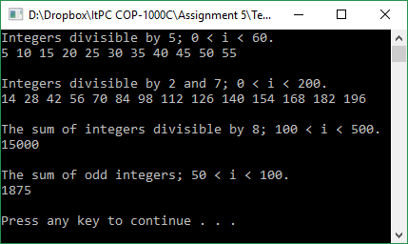 {

if ((i % 2) == 1)

sum += i;

}

printf("%i", sum);

printf("\n\n");

system("pause");

}